# CS 340 README Template

## About the Project/Project Title

*This Software enables users to interact with a database container of information about animals, providing functionality to create, read, update, and delete (CRUD) animal records.*

## Motivation

*This project was crafted to assess my proficiency in database management and data manipulation techniques.*

## Getting Started

1. *Begin by accessing Mongo and importing the CSV file named aac_shelter_outcome.csv*
2. *Subsequently, it’s essential to establish both a simple and a complex index to navigate through the stored data effectively.*
3. *To authorize users, creating both an Admin account and an aacuser account is recommended for securely accessing the database.*
4. *Finally, ensure Python is accessible or installed, and execute the program from a notebook environment.*

## Installation

* *An up-to-date version of Python is required to execute both the .py and .ipynb files.*
* *MongoDB – to access the database*

## Usage

*Use this space to show useful examples of how your project works and how it can be used. Be sure to include examples of your code, tests, and screenshots.*

### Code Example

*This Python method create is designed to handle the "C" (Create) operation in CRUD (Create, Read, Update, Delete). It inserts the provided data, which should be in dictionary format, into the MongoDB collection named animals. If the data parameter is empty or None, it raises an exception indicating that there's nothing to save.*

*This Python method read implements the "R" (Read) operation in CRUD. It retrieves data from the MongoDB collection named animals based on the provided searchData query, excluding the _id field from the result. If no query is provided, it returns all documents in the collection while still excluding the _id field.*

*This Python method update implements the "U" (Update) operation in CRUD. It updates documents in the MongoDB collection named animals based on the provided searchData query with the values specified in updateData. If updateData is provided, it executes the update operation and returns the raw result. If updateData is None, it returns an empty dictionary.*

*This Python method delete implements the "D" (Delete) operation in CRUD. It deletes documents from the MongoDB collection named animals based on the provided deleteData query. If deleteData is provided, it executes the delete operation and returns the raw result. If deleteData is None, it returns an empty dictionary.*

### Tests

*I evaluated this code by employing an invalid statement: print(animals.create(0:0)), which constitutes an invalid argument, attempting to create an unsupported data type.*

*To confirm the addition of your animal, you can execute a search using query = animals.read({"name": "NAME"}).*

### Screenshots

***

*Create*

*Search for pet “Bogey”*

*Update information for “Bogey”*

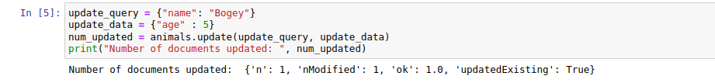

*Delete “Bogey”  
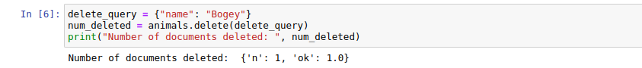*

## Contact

Your name: Brad Follett